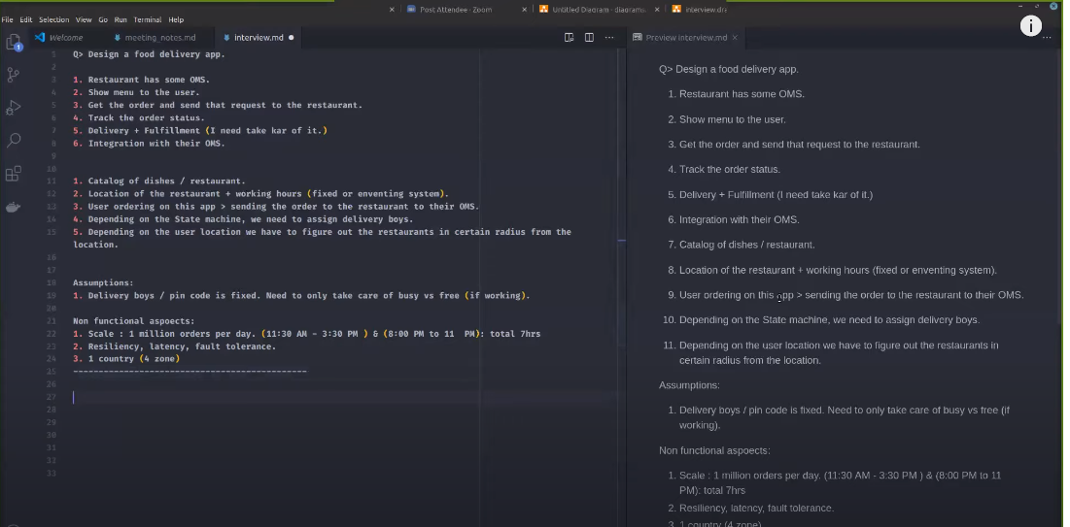

Resources: <https://www.youtube.com/watch?v=LePt0PUKIjE>

# Design a System like Uber Eats/ Door dash/ Swiggy (Senior Engineer Interview)

[](https://www.youtube.com/channel/UCUm1OB1gDV0Tl0Mjx5I01-A)

[The Stupid CS Guy](https://www.youtube.com/channel/UCUm1OB1gDV0Tl0Mjx5I01-A)